Report:
Simple Encryption and Decryption Using 8086 Assembly Language with GUI

1. Problem Statement
In today’s digital world, data security is a major concern. Plain text data can be easily accessed or modified by unauthorized users. There is a need for a simple system that can protect textual data using encryption and also restore it using decryption.
The problem addressed in this project is to design and implement a simple encryption and decryption system that:
- Accepts user input
- Encrypts alphabetic characters
- Displays encrypted output
- Decrypts the data back to its original form
- Provides both command-line (Assembly) and graphical user interface (GUI) based interaction
2. Objectives
- To understand the working of encryption and decryption
- To implement a substitution cipher using 8086 Assembly Language
- To use lookup tables for fast character mapping
- To calculate total character count
- To design a GUI using C++ WinForms API
- To integrate low-level logic with a user-friendly interface
3. Tools and Software Used
Component | Description
Language | 8086 Assembly, C++
Assembler | MASM
Emulator | DOSBox 0.74
GUI Framework | Windows API (Win32)
IDE | Dev-C++
OS | Windows

4. System Overview
The project consists of two main parts:
- Assembly Program (Core Logic)
Handles encryption, decryption, lookup tables, and character counting.
- C++ GUI Application
Provides an interactive interface for user input and output display.

5. Encryption & Decryption Technique
A substitution cipher is used in which:
- Each alphabetic character is replaced by another character
- Separate tables are maintained for:
  - Lowercase encryption
  - Lowercase decryption
  - Uppercase encryption
  - Uppercase decryption
Non-alphabetic characters remain unchanged.
6. Lookup Tables
- enc_lo → Encrypts lowercase letters
- dec_lo → Decrypts lowercase letters
- enc_up → Encrypts uppercase letters
- dec_up → Decrypts uppercase letters
In Assembly, the XLAT instruction is used for fast lookup.
In GUI, the same logic is implemented using C++ strings.
7. Flowchart
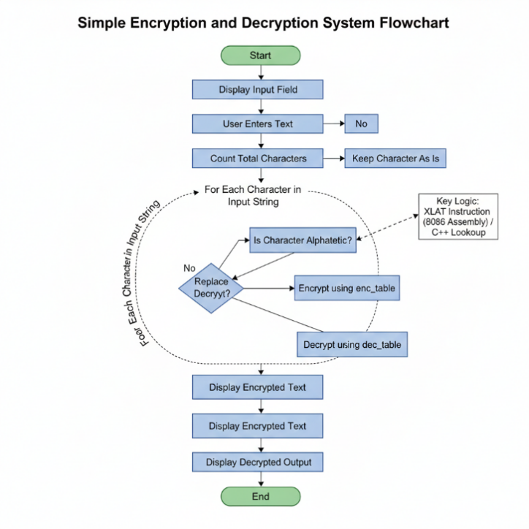

7.1 Flowchart Explanation
The flowchart illustrates the logical sequence and operational flow of the Encryption and Decryption system. The process is divided into the following key stages:
- System Initialization (Start): The process begins when the GUI application is launched. The system initializes the environment and waits for the user to interact with the input interface.
- Data Acquisition: The user enters the desired plain text into the provided input field. Upon clicking the "Process" button, the system captures this string for processing.
- Character Enumeration: Before encryption starts, the system iterates through the string to calculate the Total Character Count. This ensures the loop runs for the correct number of iterations and provides feedback to the user via the GUI.
- Character Analysis & Substitution (The Core Logic): The system processes each character individually using a loop:
  - Decision Phase: It checks if the character is an alphabet (A-Z or a-z).
  - Substitution Mapping: If it is an alphabet, the 8086 Assembly XLAT instruction is utilized. It maps the character to its encrypted counterpart using the predefined Lookup Tables (enc_lo or enc_up).
  - Bypass Logic: If the character is a digit, space, or symbol, the system skips the mapping process and retains the original character to maintain data integrity.
- Bi-Directional Processing:
  - Encryption Cycle: The plain text is transformed into cipher text and displayed in the "Encrypted" field.
  - Decryption Cycle: Immediately after encryption, the system applies the reverse logic using the decryption lookup tables (dec_lo and dec_up) to restore the data.
- Output & Termination (End): The final results, the character count, the encrypted string, and the decrypted original string are displayed simultaneously in the GUI. This confirms the accuracy of the algorithm before the process terminates.
8. Working of GUI Application
- User enters text in the input box
- On clicking Process:
  - Character count is calculated
  - Text is encrypted
  - Encrypted text is displayed
  - Encrypted text is decrypted back
- All outputs are shown in separate fields

9. Program Modules
Assembly Modules:
- print_count → Displays total characters
- crypt → Performs encryption/decryption
- map_char → Maps characters using lookup tables
GUI Modules:
- map_char() → Encrypts/decrypts one character
- crypt() → Processes complete string
- WindowProc() → Handles GUI events
- WinMain() → Application entry point

10. Output Explanation
The GUI output shows:
- Entered text
- Total character count
- Encrypted text
- Decrypted original text
The decrypted output exactly matches the input, confirming correctness.
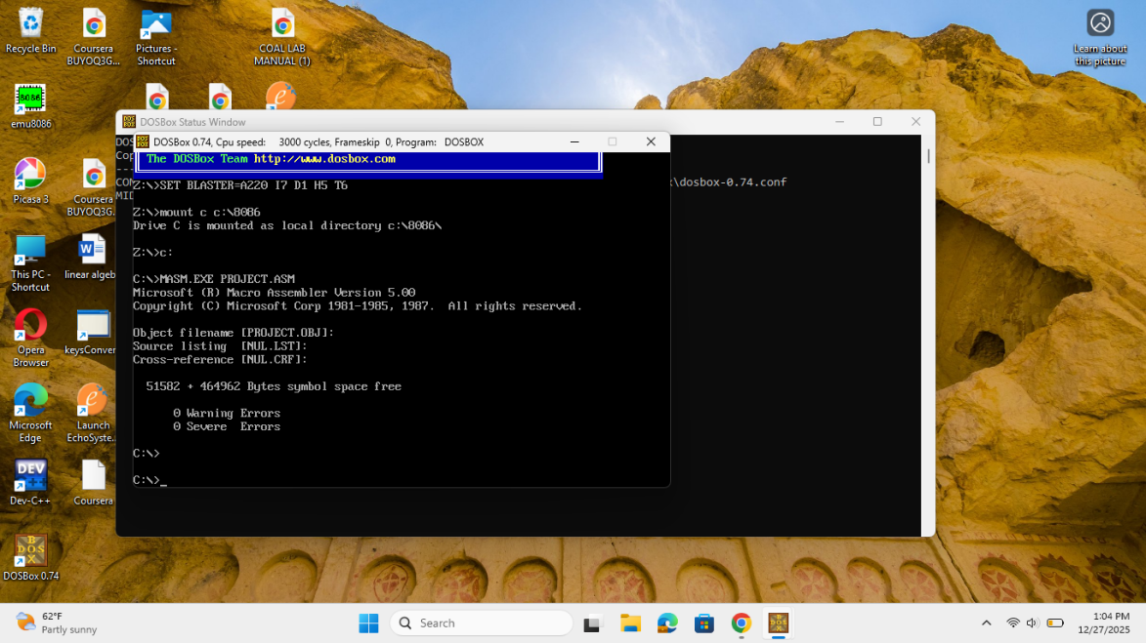
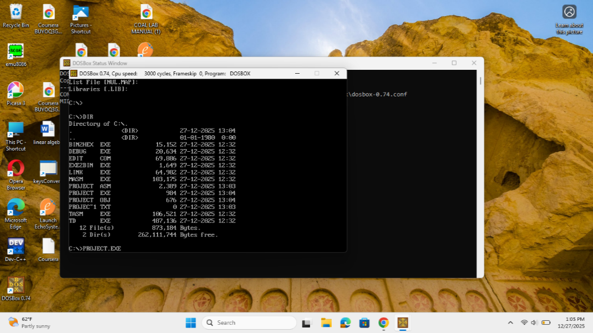
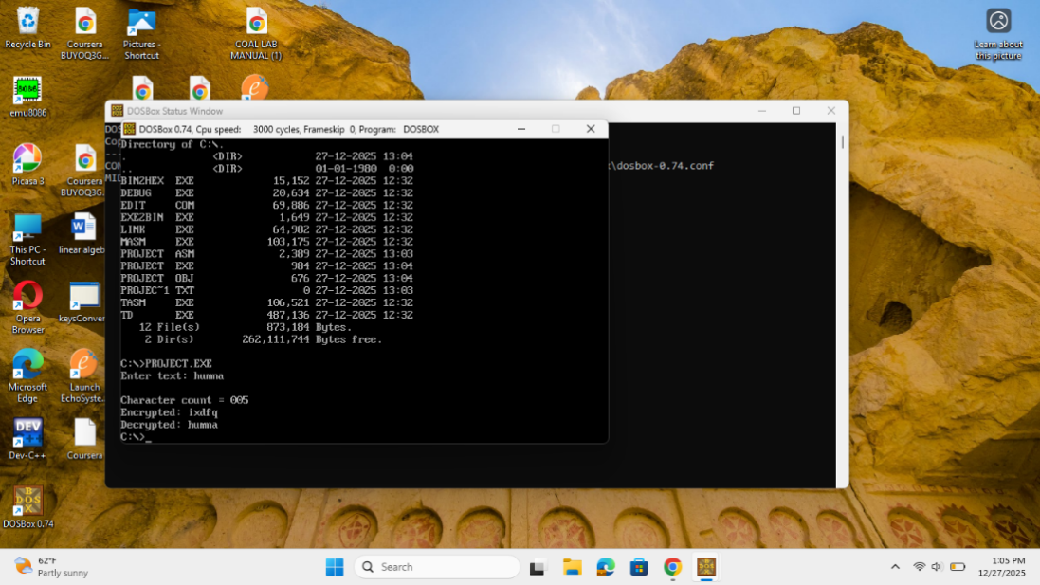
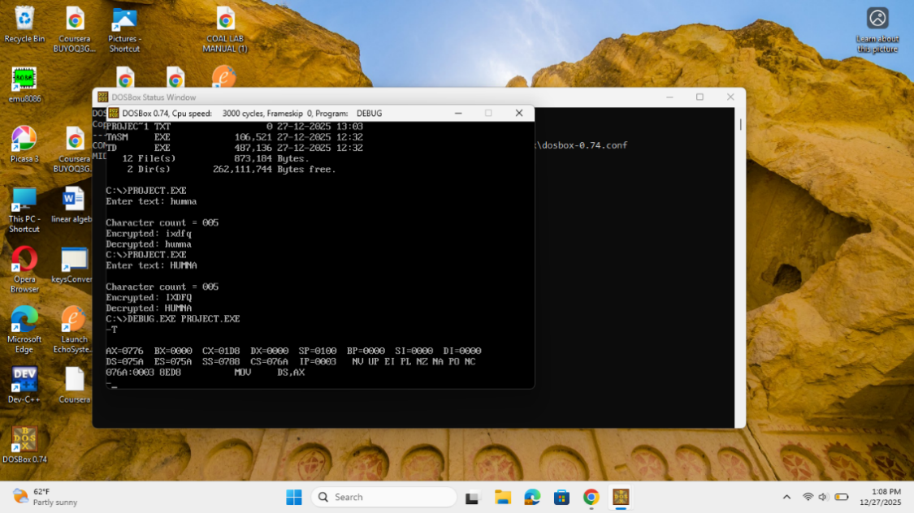
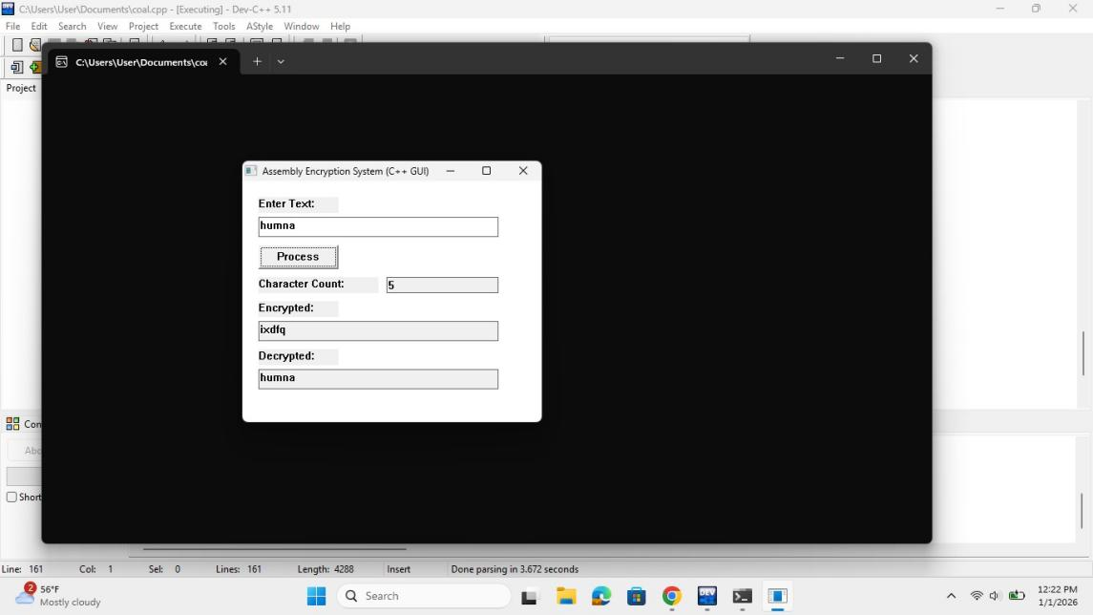

11. Advantages
- Simple and efficient design
- User-friendly GUI
- Fast encryption using lookup tables
- Supports both uppercase and lowercase letters
- Demonstrates Assembly + High-Level Language integration
12. Limitations
- Only alphabetic characters are encrypted
- No advanced cryptographic security
- Fixed substitution mapping
13. Conclusion
This project successfully demonstrates a Simple Encryption and Decryption System using 8086 Assembly Language with a C++ GUI interface. The system efficiently encrypts and decrypts user data while maintaining simplicity and clarity. It is highly useful for understanding low-level programming concepts, lookup table usage, and GUI-based interaction.

